Enable Directed Access Grandt
ប្រើ username and password to get access Token
From Keycloak

- Keycloak :

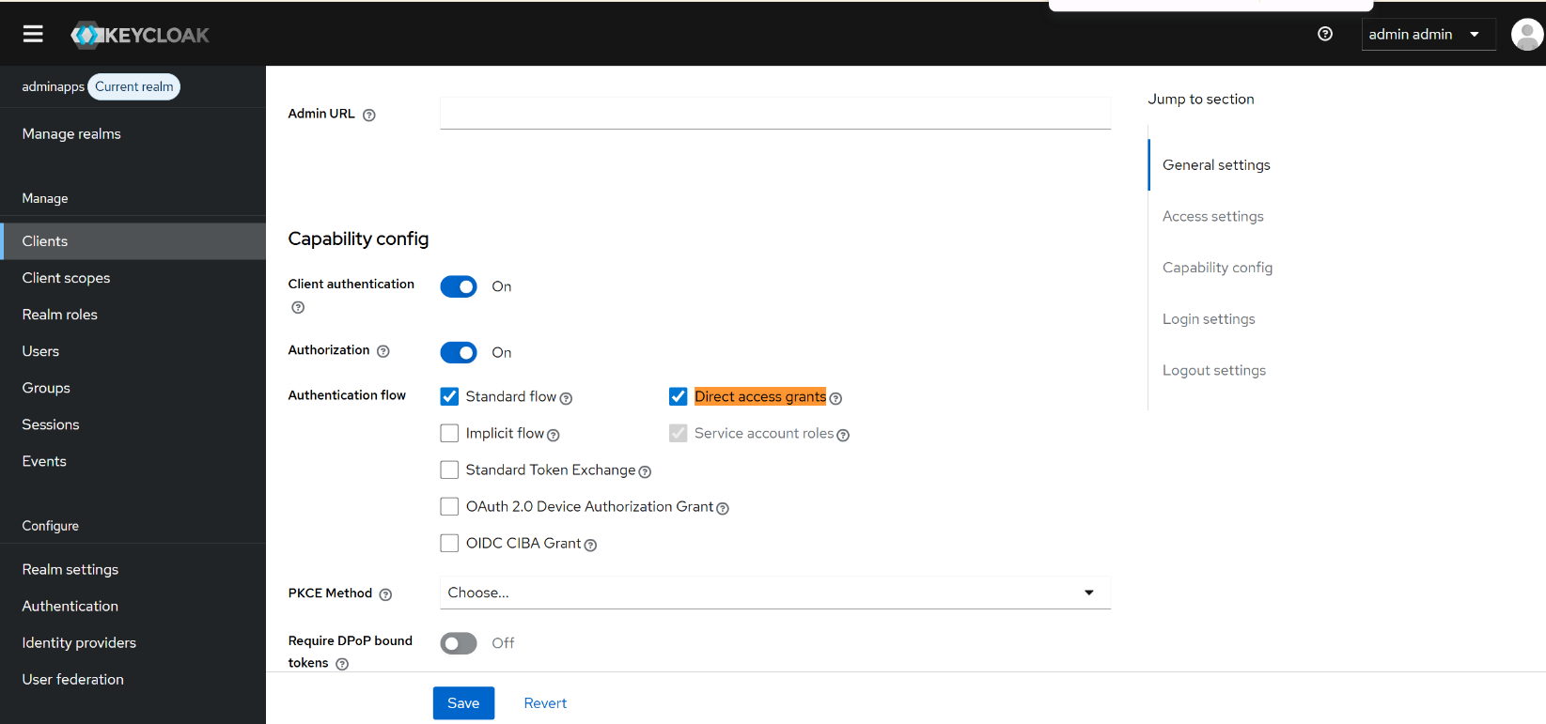

- Client application: Postman
